AI-Powered Career Guidance Agent
Project Report
Team
Quantum Coders
1. Abstract
Choosing the right career path is a challenging task for many students due to the overwhelming amount of information available and the lack of personalized guidance. Traditional career guidance methods often rely on manual counselling sessions that are time-consuming and not accessible to everyone.
To address this challenge, we developed an AI-Powered Career Guidance Agent that provides intelligent, personalized career recommendations based on a student's educational background, skills, interests, hobbies, and career goals. The system combines a modern web interface, a secure cloud database, and an AI-powered recommendation engine to help students explore suitable career options.
Unlike conventional systems that depend on lengthy assessments, our solution generates recommendations directly from the student's profile, making the experience faster, more user-friendly, and accessible.
The platform also includes an AI chatbot capable of answering career-related questions, explaining recommended career paths, and guiding students through learning roadmaps.
2. Problem Statement
Students often struggle to identify suitable career paths because:
- Career information is scattered across multiple sources.
- Students lack personalized guidance.
- Traditional counselling requires significant time and resources.
- Many platforms provide generic recommendations rather than individualized suggestions.
- Students need an interactive assistant that can answer career-related questions instantly.
Our objective was to build an intelligent system capable of providing personalized career guidance using Artificial Intelligence while maintaining a simple and intuitive user experience.
3. Objectives
The primary objectives of the project are:
- Develop an intelligent career guidance platform.
- Generate personalized career recommendations.
- Store user information securely.
- Provide an interactive AI chatbot.
- Present structured career roadmaps.
- Recommend careers based on multiple profile attributes.
- Build a scalable cloud-based architecture.
4. System Overview
The application consists of five major components.
User Authentication
Users securely register and log in using Google Authentication. Authentication is managed through Supabase Authentication, ensuring secure access and session management.
Student Profile Module
Students provide information including:
- Full Name
- Educational Qualification
- Institution
- CGPA
- Skills
- Interests
- Hobbies
- Career Goals
This information becomes the primary input for the recommendation engine.

AI Recommendation Engine
The recommendation engine analyses the student's profile and matches it with structured career information stored in the database.
The AI considers:
- Skills
- Interests
- Academic background
- Career aspirations
- User preferences
Based on these parameters, the system generates personalized career recommendations together with explanations describing why each recommendation is suitable.
Career Knowledge Base
The platform maintains a structured repository containing career-related information including:
- Career domains
- Job descriptions
- Required skills
- Career growth opportunities
- Learning roadmap
- Recommended technologies
- Educational pathways
This structured data serves as the knowledge base used by the recommendation engine.
AI Career Chatbot
The chatbot acts as an intelligent virtual career mentor.
It allows users to:
- Ask career-related questions.
- Learn about different professions.
- Understand required skills.
- Explore learning paths.
- Receive explanations for recommendations.
- Clarify doubts regarding career options.
The chatbot improves user engagement by enabling natural language interaction.
5. System Architecture
The system follows a modern client-server architecture.
Frontend Layer
Responsible for:
- User Interface
- User Interaction
- Form Validation
- Dashboard
- Recommendation Display
- Chat Interface
Developed using:
- React
- TypeScript
- HTML5
- CSS3
- Tailwind CSS
Backend Layer:
The backend is responsible for:
User authentication
Database communication
API handling
AI request processing
Recommendation generation
Secure business logic execution
Implemented using:
Supabase Backend Services
REST APIs
Edge Functions

Database Layer
Stores:
User Profiles
Career Data
Recommendation History
Chat Sessions
Authentication Information
Database Technology:
PostgreSQL (via Supabase)

AI Layer:
The AI engine processes profile information and generates intelligent recommendations by utilizing structured career knowledge and natural language understanding.
Responsibilities include:
Recommendation generation
Career explanation
Personalized guidance
Chatbot conversation
Learning roadmap generation
Technology | Purpose
React | Frontend Development
TypeScript | Type-safe application development
HTML5 | Web page structure
CSS3 | Styling
Tailwind CSS | Responsive UI Design
FastAPI (Python) | Backend API Development
Python | Backend Programming Language
REST APIs | Communication between Frontend, Backend, and AI
Qwen LLM | AI-powered career recommendation and chatbot
Database (SQL) | Storage of user profiles, career knowledge, recommendations, and chat history
Git & GitHub | Version Control
Cursor AI | AI-assisted software development, debugging, and implementation support

Development Environment and AI-Assisted Implementation
The project was designed, implemented, tested, and refined using a modern AI-assisted development workflow. During development, Cursor AI was used as an intelligent coding assistant to support the implementation process.
Cursor AI assisted the team in:
- Developing frontend components using React and TypeScript.
- Implementing backend logic and REST API integration.
- Writing and refining database queries and schema definitions.
- Integrating Supabase Authentication, PostgreSQL, and Edge Functions.
- Assisting with AI model integration and chatbot functionality.
- Debugging, code optimization, and resolving implementation issues.
- Improving code quality, maintainability, and development efficiency.
While Cursor AI accelerated software development by assisting with code generation and debugging, the overall system architecture, feature design, module integration, application workflow, technology selection, testing, and final implementation decisions were carried out by the project team.

7. Functional Modules
Module 1 – Authentication
Features:
- Google Login
- Secure Authentication
- Session Management
Module 2 – Student Profile
Stores:
- Personal Information
- Education
- Skills
- Interests
- Hobbies
- Career Goals

Module 3 – AI Recommendation
Generates:
- Suitable career paths
- Personalized explanations
- Career suggestions
- Learning recommendations
Module 4 – Career Chatbot
Supports:
- Interactive conversations
- Career exploration
- Skill guidance
- Roadmap explanation
- General career queries
Module 5 – Career Knowledge Repository
Contains:
- Career descriptions
- Required skills
- Technology stacks
- Learning resources
- Career progression information

8. Database Design
The application stores information in relational tables.
Major entities include:
Users
Stores authenticated user details.
Profiles
Stores educational background, interests, skills, hobbies, and career goals.
Careers
Stores structured career information.
Recommendations
Stores generated career recommendations for each user.
Chat History
Stores chatbot interactions for future reference.
9. Workflow
- User logs into the application using Google Authentication.
- Student profile information is collected.
- Profile data is securely stored in the cloud database.
- The AI engine processes the profile.
- Structured career information is retrieved.
- Personalized recommendations are generated.
- Career roadmaps are displayed.
- The chatbot assists users with additional queries.
- Recommendations and conversations are stored for future access.
10. Security Features
The platform incorporates multiple security mechanisms:
- Secure Google Authentication
- Role-based access through authenticated sessions
- Protected backend endpoints
- Secure cloud database
- Encrypted communication using HTTPS
- Server-side processing for sensitive operations
11. User Interface Features
The application provides:
- Responsive design
- Modern dashboard
- Interactive chatbot
- Personalized recommendation cards
- Career roadmap visualization
- User-friendly navigation
- Fast page loading
12. Achievements
The developed system successfully:
- Provides personalized career recommendations.
- Eliminates the need for lengthy career assessments.
- Delivers AI-assisted career guidance.
- Offers an intuitive conversational chatbot.
- Maintains secure cloud-based user data.
- Enables students to explore careers efficiently.
- Presents structured learning pathways for skill development.
13. Future Enhancements
The platform can be extended by introducing:
- Resume analysis
- Job market trend analysis
- Internship recommendations
- College recommendation system
- Skill gap analysis
- Industry demand prediction
- Personalized certification recommendations
- Multi-language chatbot support
- Admin analytics dashboard
- Mobile application

14.Current Limitations
Although the AI-Powered Career Guidance Agent successfully achieves its primary objectives, the current implementation has a few limitations that provide opportunities for future enhancement.
- Career recommendations are generated based on the information provided by the user. If the profile contains incomplete or inaccurate details, the quality of recommendations may be affected.
- The recommendation engine primarily relies on the structured career knowledge available in the system. Newly emerging careers or rapidly evolving industry trends require periodic updates to the knowledge base.
- The application currently focuses on personalized career guidance and does not include real-time integration with job portals or internship platforms.
- Salary information, career demand, and industry trends are based on the available structured data and are not dynamically updated from live market sources.
- The chatbot specializes in career-related guidance and may not provide accurate responses for queries outside its intended domain.
- The platform currently supports Google Authentication as the primary sign-in method. Additional authentication methods can improve accessibility for a wider range of users.
- The application is designed as a web-based platform. A dedicated mobile application is not yet available.
- Although recommendation history is stored, the system currently does not perform long-term learning from individual user interactions to further personalize future recommendations.
- Career recommendations are intended to assist users in decision-making and should complement personal interests, educational guidance, and professional counselling rather than replace them.
- The current version is optimized for students and early career learners. Additional customization would be required to support experienced professionals seeking career transitions.
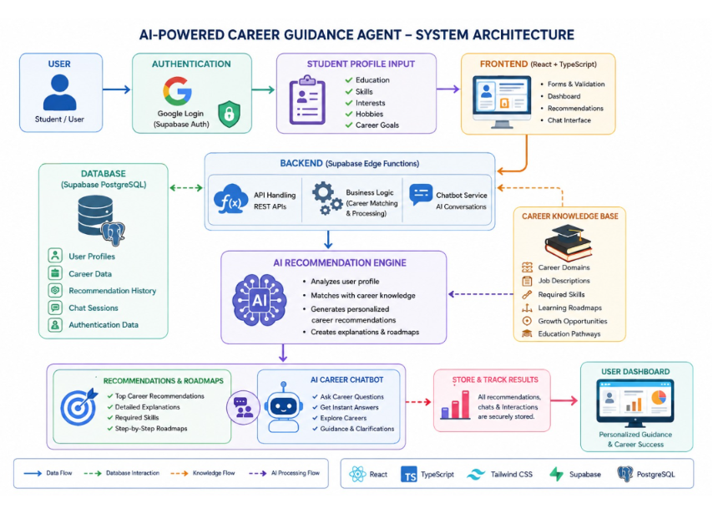

15. Conclusion
The AI-Powered Career Guidance Agent demonstrates how Artificial Intelligence can simplify career decision-making by providing intelligent, personalized recommendations based on a student's profile. The system combines modern frontend technologies, secure cloud infrastructure, scalable backend services, and AI-driven conversational assistance to create a comprehensive career guidance platform.
By integrating secure authentication, structured career knowledge, cloud-based data management, and an interactive AI chatbot, the application delivers a practical, scalable, and user-centric solution suitable for educational institutions and individual learners. The project successfully fulfills its objective of helping students explore appropriate career opportunities and learning pathways through an intelligent digital platform.

Output:

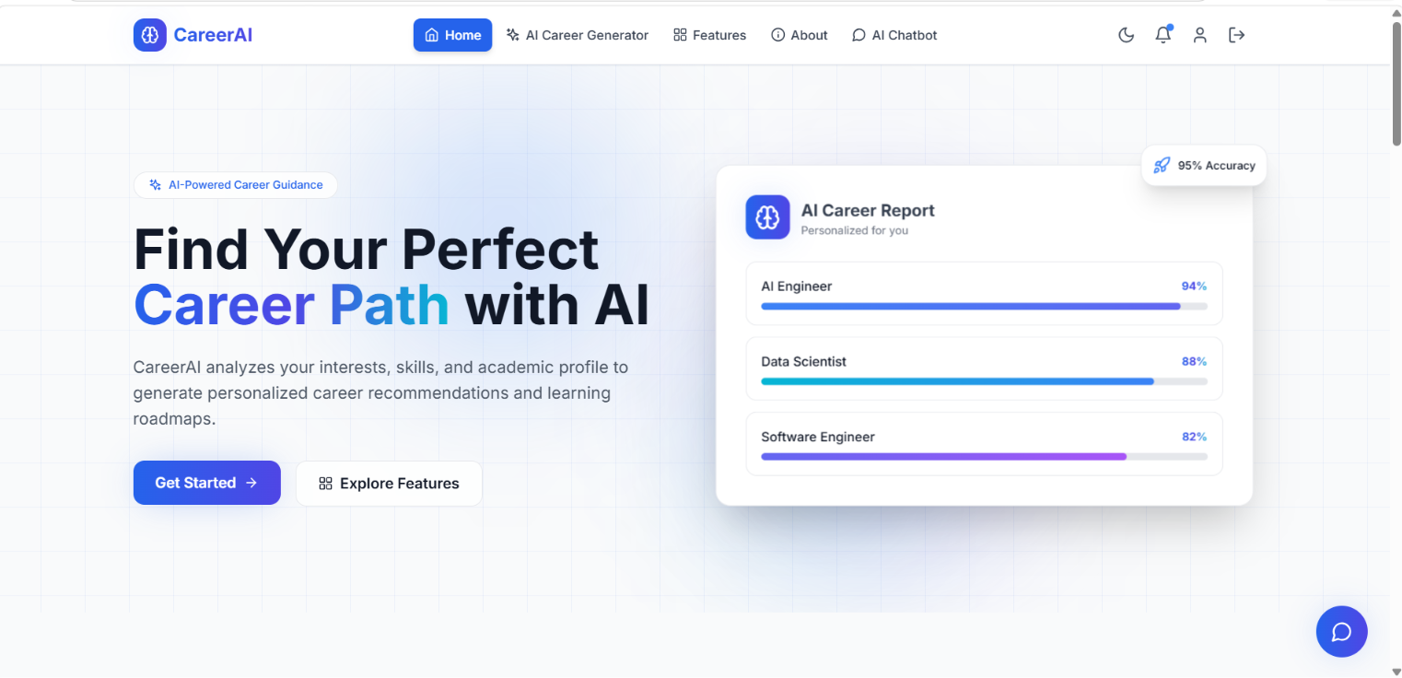

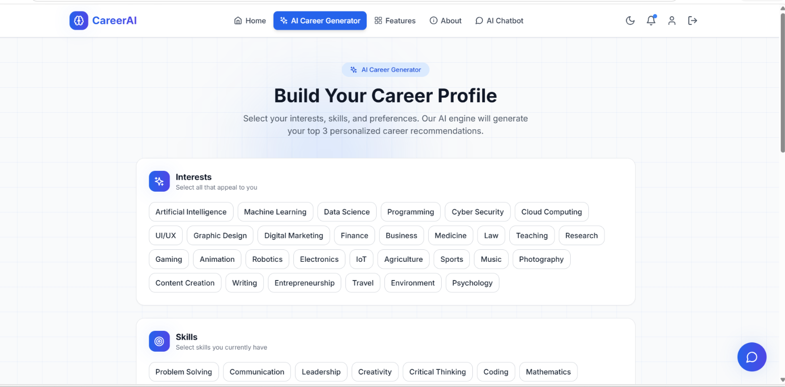

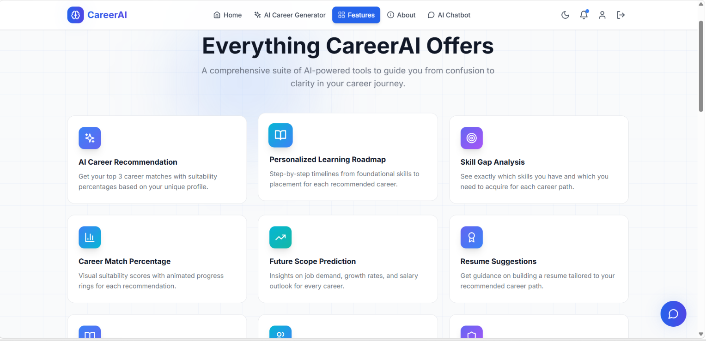

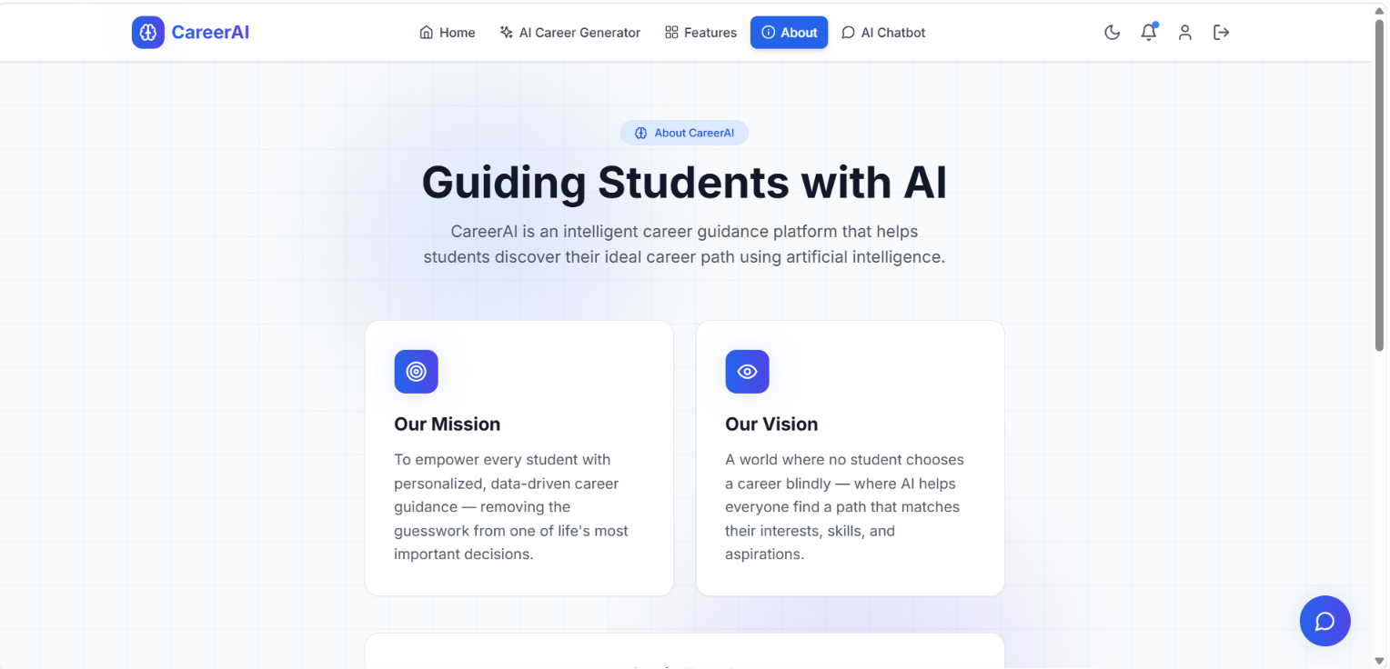

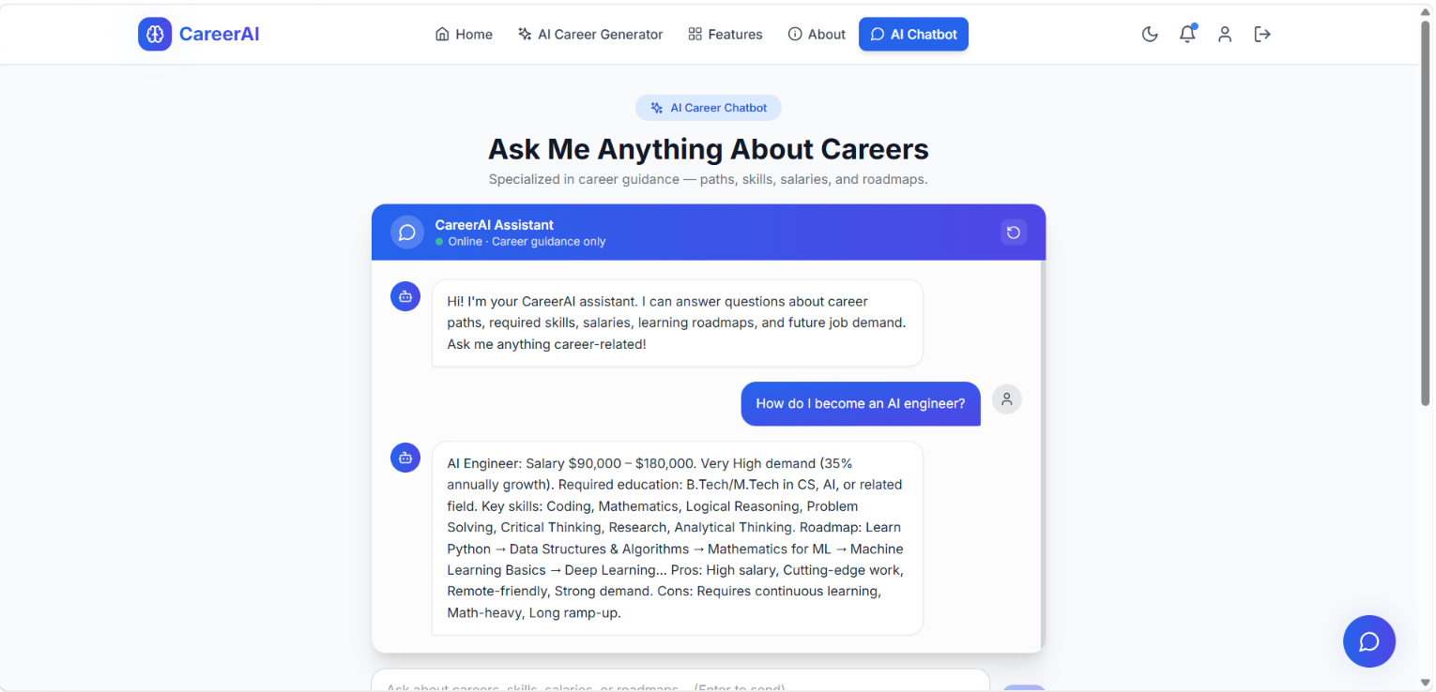

Website:
https://career-ai-team38.netlify.app/

Github link: https://github.com/kowsalyap28/QUANTUM-CODERS/tree/main/project

Code:
